Database systems

Lab 4

Hassaan Akbar Cheema

174351

# Lab Task

1. Retrieve first and last name of actors who played in AFRICAN EGG.
2. Retrieve actor id and their names with their addresses.
3. Retrieve names of movies starting with A.
4. Retrieve data of all actors whose names are not starting with Z.
5. Retrieve rental and return date for the movie ALASKA PHANTOM.
6. Find and display the Income (payments) generated during August 2005. Sort them in the descending order.
7. Find and display the Email addresses of customers who haven’t paid even a single penny yet.
8. Extract information of actors whose names ends with character ‘T’

ANS 1

Query:

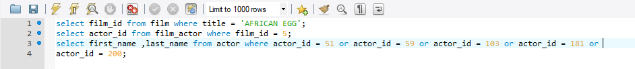

Result:

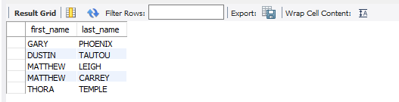

ANS 2

Query:

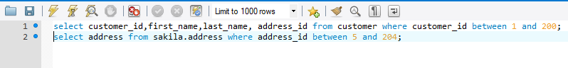

Result:

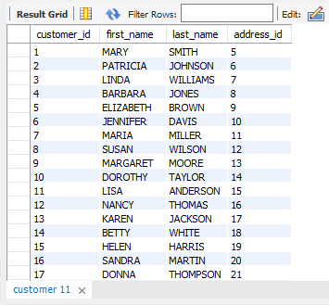

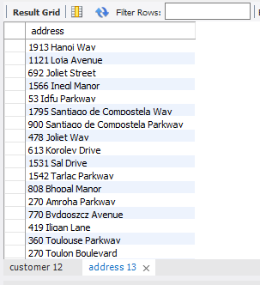

ANS 3

Query:

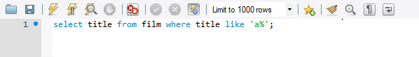

Result:

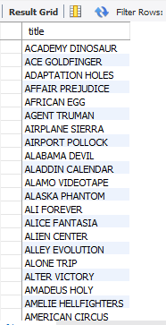

ANS 4

Query:

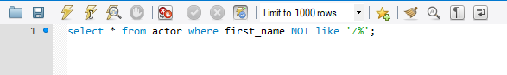

Result:

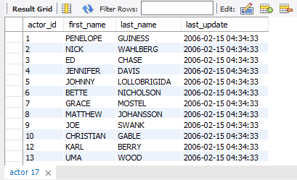

ANS 5

Query:

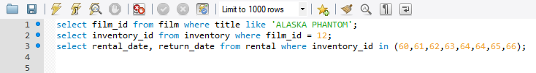

Result:

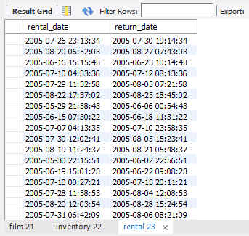

ANS 6

Query:



Result:

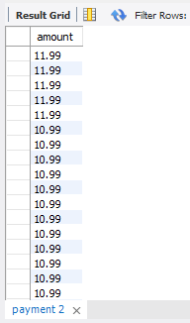

ANS 7

Query:

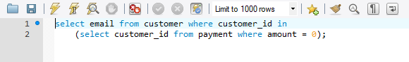

Result:

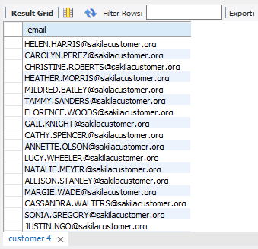

ANS 8

Query:



Result:

